Assessing the Impact of Poplars in Silvoarable Systems on Microclimate and Soybean yield

Simone Piotto¹, Anna Panozzo¹, Gaia Pasqualotto², Vinicio Carraro², Giuseppe Barion¹, Stefano Nale³, Lorenzo Furlan³, Tommaso Anfodillo², Teofilo Vamerali¹

¹ Dep. of Agronomy, Food, Natural Resources, Animals and the Environment, University of Padova, 35020 Legnaro, IT
simone.piotto.1@phd.unipd.it; anna.panozzo@unipd.it; giuseppe.barion@unipd.it; teofilo.vamerali@unipd.it
² Department of Land, Environment, Agriculture and Forestry, University of Padua, 35020 Legnaro, IT
gaia.pasqualotto@unipd.it; vinicio.carraro@unipd.it; tommaso.anfodillo@unipd.it
³ Agenzia Veneta per l’Innovazione nel Settore Primario – Veneto Agricoltura, 35020 Legnaro, IT
stefano.nale@venetoagricoltura.org; lorenzo.furlan@venetoagricoltura.org

Introduction
Given the pressing concern over food security in the next 20 years due to increased population and at least locally decreased food supply resulting from climate stresses, agricultural systems must be a key focus on adaptation strategies to climate change (Matocha et al., 2012). Among different solutions, agroforestry systems are capable to improve resilience of farmers utilizing more efficiently environmental resources and establishing a better microclimate for associated crops (Lasco et al., 2014). These benefits could be interesting in Po valley context, which is one of the most threatened regions by climate change effects. In the last couple of years it faced one of the worst droughts ever and considering that the frequency of drought periods is increased and will increase more and more in future (Straffelini & Tarolli, 2023), understanding how trees are able to mitigate environmental conditions for associated crops in silvoarable systems could become important for the design of agricultural systems of the future. In this study it was evaluated in a poplar alley-cropping system how different environmental parameters (i.e. PAR, air temperature, VPD and soil water potential) and soybean yield (which being a summer crop is more penalised by tree shading) change in the proximity of tree rows.

Materials and Methods
The trial was carried out from the end of May to the end of August 2022 in a silvoarable alley-cropping system with different clones of poplar trees (Populus × euroamericana) type HES (Higher Environmental Sustainability) located at the “Sasse Rami” pilot farm of Veneto Agricoltura, in Ceregnano (Rovigo, NE Italy, 45° 05’06” N, 11° 87’ 66” W; 0.5-1m a.s.l.). In the alley-cropping system tree rows are 40 m apart NS oriented, placed along drainage ditches ~150 m long, with 6 m between trees along the row (~40 trees ha⁻¹). Environmental parameters and soybean yield have been determined at different distances along transects orthogonal to tree rows both at east (E) and west (W) sides, named ¼H, ½H, H and FS, where H=tree height (12m) and FS=middle of the inter-row (20m; assumed as control). PAR was determined in both sides in ½H, H and FS (SQ-202X-SS, Apogee Instruments, Inc.), air temperature and VPD were determined in both sides in ½H and FS (ATMOS14, METER Group, Inc.), soil water potential was determined in the west side in ½H, H and FS at 0,3 m and 0,6 m (TEROS21, METER Group, Inc.), and soybean yield (var. Nirvana; ERSA – Gorizia, Italy) was determined in both sides and all distances. Statistical analyses were carried out with R studio v. 1.4, using the Tukey’s HSD test for means separation (P≤0.05) and two-sample t-test (p ≤ 0.05).

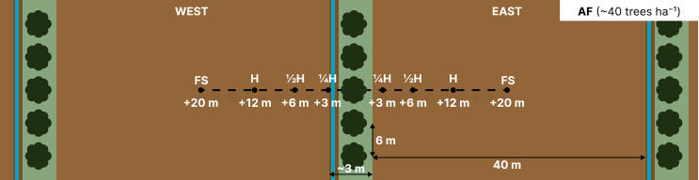
Figure 1: Scheme of sampling points along the transects.
Results
If compared to FS, PAR transmission was lower at west during the morning from 9:00 to 10:00 in H (-56%; p ≤ 0.05) and from 9:00 to 12:00 in ½H (-52%; p ≤ 0.05), while at east from 14:00 to 15:00 in H (-66%; p ≤ 0.05) and from 6:00 to 14:00 in ½H, with the highest differences from 11:00 to 13:00 (-27%; p ≤ 0.05) (Fig. 2, above left). Moreover, in the late afternoon and only at west in early morning, values were higher in ½H and in H vs. FS.
Soil water potential from the first of June to the 15th of August at -30 cm was significantly lower by 34% in H and by 10% in ½H vs. FS (-698 in H and -959 in ½H vs. -1062 in FS; p ≤ 0.01) (Fig. 2, above right). However, the minor difference in ½H was also influenced by lower crop development.
VPD and air temperature difference between ½H and FS were lower during the central hours of the day in ½H vs. FS in the morning at the west and in the afternoon at the east of poplar rows, especially in the hottest days. From 19:00 to 8:00 and mainly in early morning, air temperature was slightly higher, with the highest differences in the hottest days (Fig. 2, VPD below left and air temperature below right).
Soybean yield was comparable to C in H (-1%), slightly lower in ½H (-11%) and lower in ¼H at east (-24%) and significantly lower at west (-64%; p ≤ 0.001).

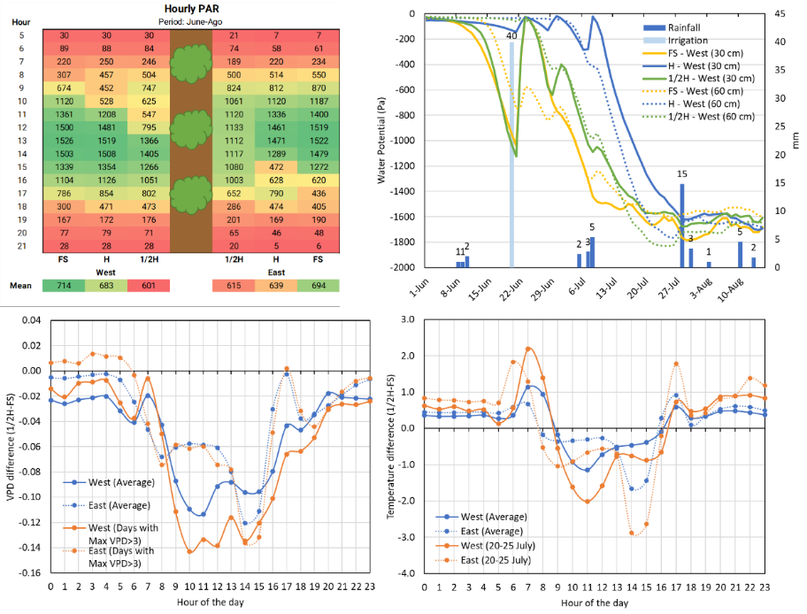

Figure 2: Above left, Hourly average PAR transmission from June to August; above right, soil water potential at 0,3 m and 0,6 m at ½H, H and FS; below left, hourly VPD difference from ½H and FS from June to August; below right, hourly air temperature difference from ½H and FS from June to August.

Conclusions
In their proximity, poplar rows positively influence microclimate by lowering air temperature and VPD and by increasing soil humidity, but penalise PAR transmission in the morning at the west and in the afternoon at the east. However, soybean yield was penalised only slightly compared to other studies, with significantly lower values only very close at the west of poplar rows. These results could also demonstrate that summer crop yield could be less affected by limited sunlight radiation in water scarcity conditions.

Literature
Matocha J., Schroth G., Hills T., Hole D. (2012). Integrating Climate Change Adaptation and Mitigation Through Agroforestry and Ecosystem Conservation. Agroforestry - The Future of Global Land Use. 105-126.
Lasco R. D., Delfino R. J. P., Catacutan D. C., Simelton E. S., Wilson D. M. (2014). Climate risk adaptation by smallholder farmers: the roles of trees and agroforestry. Current Opinion in Environmental Sustainability. 6:83-88
Straffelini E., Tarolli P. (2023). Climate change-induced aridity is affecting agriculture in Northeast Italy. Agricultural systems. 208: 103647.

