Supporting Information
Hydrophobic hybrid silica sol-gel coating on aluminium: stability evaluation during saturated vapour condensation
Authors: Maria Basso, Elena Colusso, Marco Tancon, Stefano Bortolin, Matteo Mirafiori, Massimo Guglielmi, Davide Del Col, Alessandro Martucci*
Affiliation: Università di Padova, Dipartimento di Ingegneria Industriale, Padova, Italy
*corresponding author: alex.martucci@unipd.it

Description of experimental apparatus for condensation tests.
Layout of the experimental thermosyphon loop used for condensation tests.

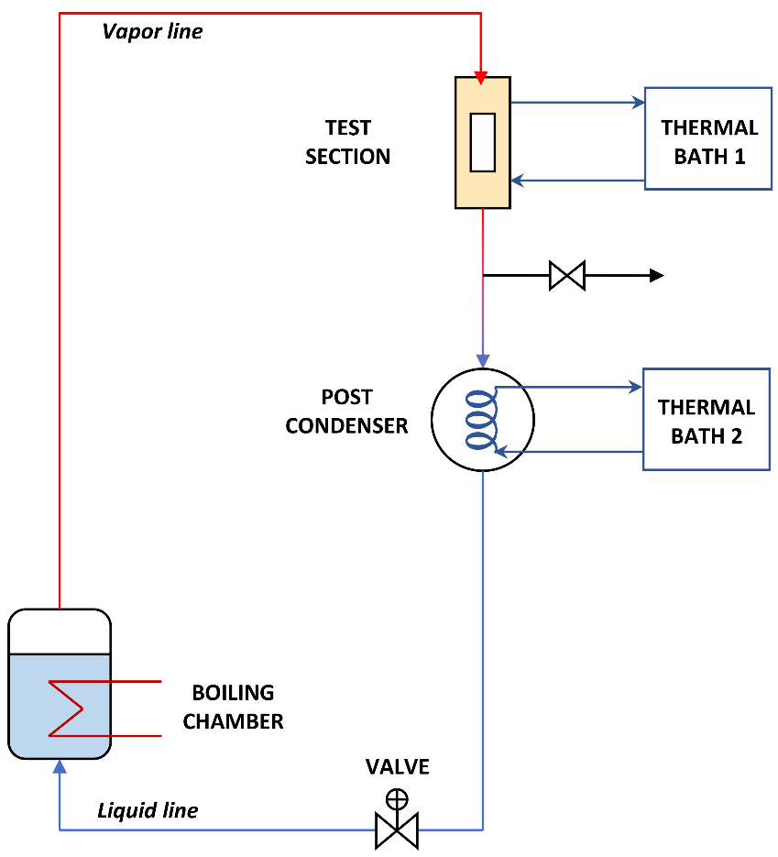
Figure S1. Layout of the thermosiphon loop used during DWC tests.
Detailed description of the calculation of the heat transfer coefficient
Since the temperature difference between the inlet and outlet of the test section and the water mass flow rate are measured, the average condensation heat flux during DWC (q_{mean}) can be evaluated from the thermal balance at the coolant side of the test section. Each substrate is equipped with six T-type thermocouples arranged at two different depths from the coated surface (z₁ = 1.3 mm and z₂ = 2.8 mm) and in correspondence of three longitudinal positions along the sample (top, middle, and bottom). According to the Fourier’s law for thermal conduction, the thermocouples inserted in the sample at depth z₁ and the temperature gradient associated to the mean condensation heat flux q_{mean} give the local surface temperature (T_{wall,loc}) for each of the three longitudinal positions. In the present work, the three temperature differences between the saturation temperature and the local surface temperature (ΔT_{loc} = T_{sat} – T_{wall,loc}) are used to calculate the average wall subcooling over the whole condensing surface (ΔT). Hence, the mean HTC during dropwise condensation is evaluated as:
$$HTC=\frac{q_{mean}}{∆T}$$ | (1)
Each experimental data reported in this paper is the mean of 480 readings acquired at 1 Hz with error bars representing the expanded combined uncertainty calculated considering a coverage factor k = 2.
Condensation tests to assess the coating robustness over time were performed at the following thermodynamic conditions: 106 °C of saturation temperature (which corresponds to a saturation pressure of 1.24 bar), 2.9 m s⁻¹ of steam velocity, heat flux in the range 250-550 kW m⁻². As previously said, the test rig is a two-phase thermosiphon and, therefore, the velocity of the vapor inside the test section cannot be zero. However, since the vapor velocity is maintained below 3 m s⁻¹, its effect on the HTC can be considered negligible as shown in previous works³¹. To avoid the penalizing effect of non-condensable gases on the heat transfer coefficient, the experimental apparatus always works at a pressure higher than the atmospheric one.

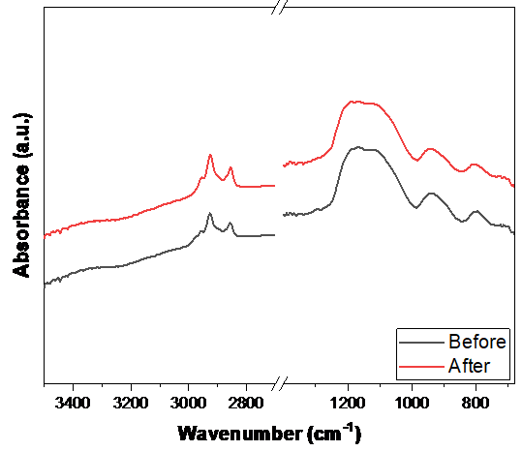
Figure S2. FTIR spectroscopy absorption spectra of the coating on aluminium before and after the 7 h condensation tests in the experimental apparatus.

 | Before | After
Si-OH | 238 | 237
Si-O-Si | 492 | 492
Si-OH/Si-O-Si (%) | 48 | 48
Table S1. Peak intensity and ratio between Si-OH peak and Si-O-Si peaks from FTIR spectroscopy, before after the 7 h degradation tests of the coatings on aluminium.

 | S-100 | PB | I-90 | I-20 | T-100 | Ref
Si-OH | 1,76 | 0,95 | 1,62 | 1,55 | 2,21 | 1,69
Si-O-Si | 29,69 | 21,14 | 31,51 | 29,65 | 41,81 | 31,34
Si-OH/Si-O-Si (%) | 6 | 5 | 5 | 5 | 5 | 5
Table S2. Peak intensity and ratio between Si-OH peak and Si-O-Si peak from FTIR spectroscopy, before and after the 7 h degradation tests of the coatings on silicon wafers.

Test | Before (nm) | After (nm) | Delta (nm)
T-100 | 319 ± 1 | 320 ± 1 | -
I-20 | 324 ± 7 | 324 ± 4 | -
S-100 | 324 ± 4 | 323 ± 1 | -
I-90 | 324 ± 1 | 328 ± 7 | -
PB | 323 ± 1 | 243 ± 19 | - 80 ± 20
Table S3. Ellipsometry measurements of the thickness before and after the degradation tests for each sample, with the corresponding standard deviation value.

 | Before | After
ACA (°) | 96 ± 5 | 97 ± 5
RCA (°) | 87 ± 5 | < 10°
Thickness (nm) | 266 ± 10 | 228 ± 7
Table S4. Water contact angles (ACA, RCA) and thickness before and after the PB test on the coated aluminium sample, with the corresponding standard deviation value.

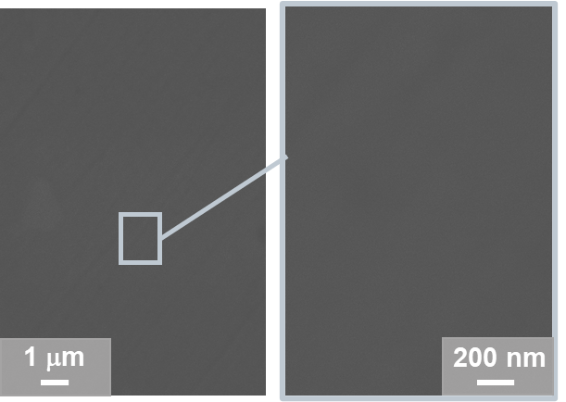
Figure S3. SEM images of the reference small aluminium sample. The scale bar is reported on the bottom right corner of each image.

