A feasibility study of the Therapeutic Application of a Mixture of ^{67/64}Cu Radioisotopes produced by cyclotrons with proton irradiation

Supplemental data

Table S-1. Parameters of the ICRU 53 biokinetic model used to calculate CuCl₂ organ uptake.

Organ | F_{s} | T_{i} [days] | a_{i}
Total body | 1.0 | 10 | 1.0
Brain | 0.1 | 10 | 1.0
Liver | 0.65 | 0.5 | 0.15
Liver | 0.65 | 1.5 | 0.33
Liver | 0.65 | 10 | 0.52
Kidneys | 0.01 | 10 | 1.0
Pancreas | 0.002 | 10 | 1.0

Table S-2. Main decay characteristics of the radionuclides ⁶⁴Cu, ⁶⁷Cu, and ¹⁷⁷Lu.

Radioisotope | ⁶⁴Cu |  |  | ⁶⁷Cu |  |  | ¹⁷⁷Lu
Half-life | 12.700 h |  |  | 61.83 h |  |  | 159.528 h
Decay mode | EC, β⁺, β⁻ |  |  | β⁻ |  |  | β⁻
Radiations | Yield  (/nt) | Energy (MeV/nt) | Mean energy (MeV) | Yield  (/nt) | Energy (MeV/nt) | Mean energy (MeV) | Yield  (/nt) | Energy (MeV/nt) | Mean energy (MeV)
Gamma rays | 4.734∙10⁻³ | 6.37∙10⁻³ | 1.346 | 7.293∙10⁻¹ | 1.148∙10⁻¹ | 1.574∙10⁻¹ | 1.803∙10⁻¹ | 3.156∙10⁻² | 1.750∙10⁻¹
X rays | 2.403 | 1.202∙10⁻³ | 5.001∙10⁻⁴ | 7.759∙10⁻¹ | 5.553∙10⁻⁴ | 7.157∙10⁻⁴ | 1.374 | 3.540∙10⁻³ | 2.576∙10⁻³
Annh. Photons | 3.482∙10⁻¹ | 1.779∙10⁻¹ | 5.11∙10⁻¹ | - | - | - | -
Tot photons |  | 1.855∙10⁻¹ |  |  | 1.154∙10⁻¹ |  |  | 3.51∙10⁻²
β⁺ | 1.741∙10⁻¹ | 4.843∙10⁻² | 2.782∙10⁻¹ | - | - | -
β⁻ | 3.900∙10⁻¹ | 7.427∙10⁻² | 1.904∙10⁻¹ | 1.00 | 1.359∙10⁻¹ | 1.359∙10⁻¹ | 1.00 | 1.333∙10⁻¹ | 1.333∙10⁻¹
IC electrons | 5.777∙10⁻⁷ | 7.73∙10⁻⁷ | 1.338 | 1.528∙10⁻¹ | 1.374∙10⁻² | 8.995∙10⁻² | 1.548∙10⁻¹ | 1.352∙10⁻² | 8.737∙10⁻²
Auger electrons | 1.807 | 2.05∙10⁻³ | 1.134∙10⁻³ | 5.588∙10⁻¹ | 7.510∙10⁻⁴ | 1.344∙10⁻³ | 1.117 | 1.132∙10⁻³ | 1.014∙10⁻³
Tot electrons |  | 1.248∙10⁻¹ |  |  | 1.504∙10⁻¹ |  |  | 1.479∙10⁻¹

Table S-3. S-values calculated for different radionuclides using MIRDcell program and considering different distances between the target and the source cells.

Distance  (µm) | ⁶⁴Cu |  | ⁶⁷Cu |  | ¹⁷⁷Lu
Distance  (µm) | S(c ⃪ c)  (Gy/Bq.s) | S(n ⃪ cy)  (Gy/Bq.s) | S(c ⃪ c)  (Gy/Bq.s) | S(n ⃪ cy)  (Gy/Bq.s) | S(c ⃪ c)  (Gy/Bq.s) | S(n ⃪ cy)  (Gy/Bq.s)
Self-S | 1.34E-04 | 6.39E-05 | 1.87E-04 | 1.52E-04 | 2.11E-04 | 1.64E-04
20 | 6.71E-06 | 6.19E-06 | 1.78E-05 | 1.64E-05 | 1.90E-05 | 1.74E-05
25 | 3.93E-06 | 3.78E-06 | 1.04E-05 | 9.94E-06 | 1.11E-05 | 1.06E-05
30 | 2.62E-06 | 2.56E-06 | 6.85E-06 | 6.69E-06 | 7.44E-06 | 7.30E-06
35 | 1.87E-06 | 1.84E-06 | 4.88E-06 | 4.80E-06 | 5.32E-06 | 5.31E-06
40 | 1.41E-06 | 1.39E-06 | 3.65E-06 | 3.60E-06 | 3.86E-06 | 3.84E-06
45 | 1.09E-06 | 1.08E-06 | 2.82E-06 | 2.80E-06 | 2.80E-06 | 2.75E-06
50 | 8.70E-07 | 8.64E-07 | 2.25E-06 | 2.23E-06 | 2.08E-06 | 2.01E-06
55 | 7.09E-07 | 7.05E-07 | 1.83E-06 | 1.82E-06 | 1.62E-06 | 1.60E-06
60 | 5.88E-07 | 5.85E-07 | 1.53E-06 | 1.52E-06 | 1.32E-06 | 1.32E-06
65 | 4.95E-07 | 4.93E-07 | 1.29E-06 | 1.28E-06 | 1.10E-06 | 1.10E-06
70 | 4.22E-07 | 4.21E-07 | 1.11E-06 | 1.10E-06 | 9.33E-07 | 9.29E-07
75 | 3.64E-07 | 3.62E-07 | 9.66E-07 | 9.61E-07 | 7.98E-07 | 7.93E-07
80 | 3.17E-07 | 3.16E-07 | 8.54E-07 | 8.52E-07 | 6.89E-07 | 6.88E-07
85 | 2.78E-07 | 2.76E-07 | 7.69E-07 | 7.62E-07 | 6.01E-07 | 5.97E-07
90 | 2.45E-07 | 2.45E-07 | 7.09E-07 | 7.03E-07 | 5.27E-07 | 5.28E-07
95 | 2.18E-07 | 2.17E-07 | 6.68E-07 | 6.70E-07 | 4.67E-07 | 4.64E-07
100 | 1.95E-07 | 1.95E-07 | 6.11E-07 | 6.36E-07 | 4.16E-07 | 4.17E-07
105 | 1.75E-07 | 1.74E-07 | 5.17E-07 | 5.26E-07 | 3.73E-07 | 3.72E-07
110 | 1.58E-07 | 1.58E-07 | 4.03E-07 | 3.99E-07 | 3.37E-07 | 3.36E-07
115 | 1.42E-07 | 1.42E-07 | 3.12E-07 | 2.94E-07 | 3.05E-07 | 3.05E-07
120 | 1.29E-07 | 1.28E-07 | 2.58E-07 | 2.55E-07 | 2.77E-07 | 2.75E-07
124 | 1.20E-07 | 1.19E-07 | 2.32E-07 | 2.32E-07 | 2.59E-07 | 2.57E-07

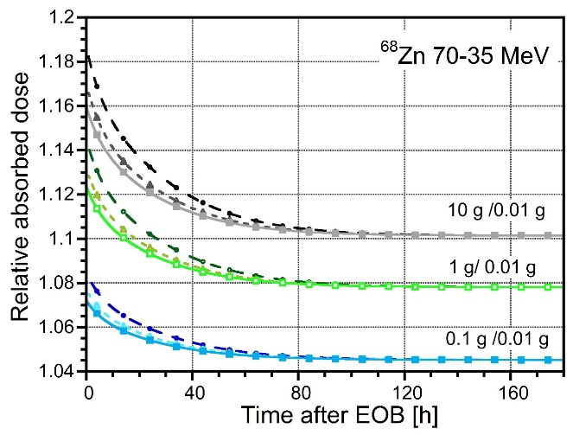A)
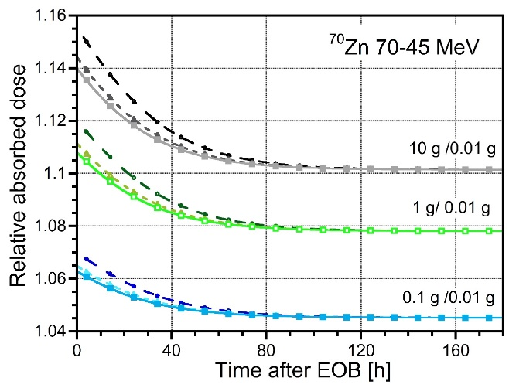B)
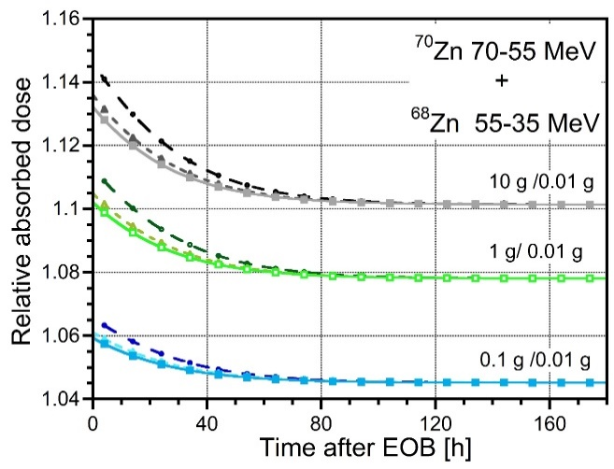C)
Figure S-1. Relative absorbed dose to spheres of different mass (0.1 g, 1 g and 10 g) compared to that of 0.01 g, resulting from a uniform concentration of events (1 decay for μm³) and injection of the ^{67/64}CuCl₂ mixture obtained with 1 μA proton beam and different irradiation times (circles: 62 h; triangles: 124 h; squares: 185 h) of A) a ⁶⁸Zn target in the energy range 70-35 MeV; B) a ⁷⁰Zn target in the energy range 70-45 MeV; C) a composite ⁷⁰Zn-⁶⁸Zn target in the energy range 70-55 MeV and 55-35 MeV, respectively.

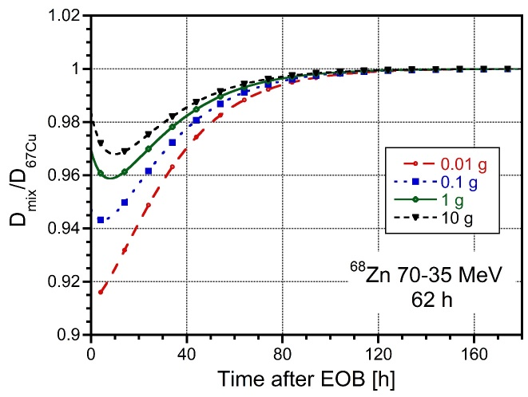A)
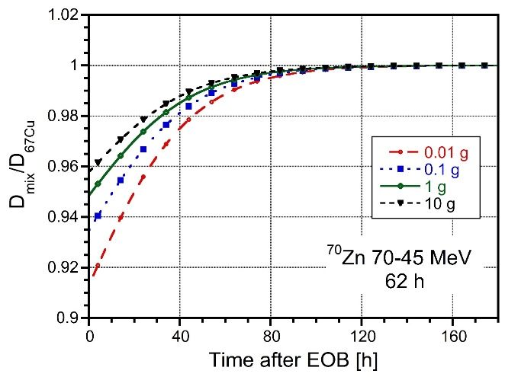B)
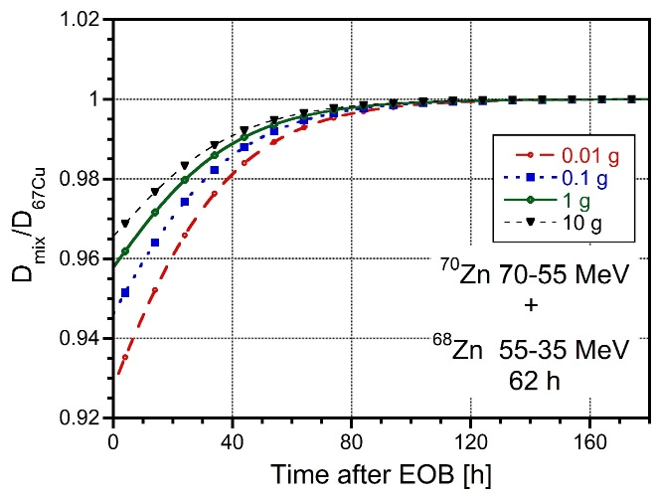C)

Figure S-2. Relative absorbed dose (D_{mix}/D_{67Cu}) to spheres of different mass (0.01 g, 0.1 g, 1 g and 10 g), resulting from a uniform concentration of events (1 decay for μm³) and injection of the ^{67/64}CuCl₂ mixture obtained with 1 μA proton beam and 62 h of irradiation of A) a ⁶⁸Zn target in the energy range 70-35 MeV; B) a ⁷⁰Zn target in the energy range 70-45 MeV; C) a composite ⁷⁰Zn-⁶⁸Zn target in the energy range 70-55 MeV and 55-35 MeV, respectively.

