DOI: 10.1002/ ((please add manuscript number))
Article type: Full paper

Title: Multiple reaction paths for CO oxidation on a two dimensional SnO_{x} nanoxide on the Pt(110) surface: intrinsic reactivity and spillover

Jian Zheng, Michael Busch, Luca Artiglia, Tomáš Skála, Jan Rossmeisl, Stefano Agnoli*

Dr. Jian Zheng, Prof. Stefano Agnoli
Department of Chemical Sciences and INSTM UNIT, University of Padova, Via Marzolo, 1, I-35131 Padova, Italy
E-mail: stefano.agnoli@unipd.it
Dr. Michael Busch
Dr. Luca Artiglia
Laboratory for Catalysis and Sustainable Chemistry and Laboratory of Environmental Chemistry, Paul Scherrer Institute, Forschungsstrasse 111, 5232 Villigen PSI, Switzerland.
Center for Atomic-Scale Materials Design, Department of Physics, Technical University of Denmark, DK-2800 Kongens Lyngby, Denmark
Dr.Tomáš Skála
§Faculty of Mathematics and Physics, Department of Surface and Plasma Science, Charles University, V Holešovičkách 2, CZ-18000Prague, Czech Republic
Prof. Jan Rossmeisl
Nano-Science Center, Department of Chemistry, University of Copenhagen, Universitetsparken 5, DK-2100 Copenhagen, Denmark

Keywords: nano-oxide, photoemission spectroscopy, STM, DFT, CO reactivity

An interfase stabilized SnO_{x}/Pt(110) nano-oxide characterized by a c(2×4) surface reconstruction is prepared and characterized by low energy electron diffraction (LEED), synchrotron radiation photoemission spectroscopy (SRPES) and scanning tunneling microscopy (STM). Based on the experimental data, atomic models for the nano-oxide are proposed and then validated by comparing the experimental results with the outcome of first-principle calculations. The reactivity of the nano-oxide toward CO is investigated, obtaining that the c(2×4) reconstruction efficiently oxidizes CO to CO₂. The SnO_{x} nano-oxide on the Pt(110) surface can act as a reservoir for oxygen that can diffuse on the adjacent Pt areas where it oxidizes CO. This spillover effect endows the SnO_{x}/Pt(110) system with enhanced tolerance to CO poisoning.

- Introduction
Nowadays, the global economy relies on traditional fossil fuels. However, their excessive exploitation is leading to a fast increase of the global temperature as a consequence of the large amount of CO₂ emissions.^{[1]} Additionally, the pollution produced by the increasing amount of cars using gasoline or diesel combustion engines, impacts the air quality. Therefore, finding alternatives to fossil fuels is one of the biggest challenges of modern society.^{[2]}
Among the several routes to satisfy the energy demand, fuel cells (FCs) have drawn a great deal of attention due to their high conversion efficiency,^{[3]} limited environmental impact^{[3]} and portability, which may offer a solution to the distributed energy requirements. In this context, proton exchange membrane fuel cells (PEMFCs), direct methanol/ethanol fuel cells (DMFC/DEFC) are expected to be progressively used in daily applications.
The electrocatalysts needed at the FCs electrodes can be based either on metal nanoparticles,^{[4]} or on atomically dispersed molecular compounds that often mimic well-known active sites found in some natural enzymes.^{[5]} Nowadays, platinum is acknowledged as the most active metal for the cathodic compartment of FC; however it is a critical raw material and its limited durability and high cost have so far prevented a pervasive diffusion of the FCs technology.^{[6]} As an example, Pt-based electrocatalysts are quickly poisoned by CO,^{[7]} one of the main impurities of the H₂ fuel, which may cross through the membrane from the anode to the cathode. On the another hand, the CO can be generated and adsorbed on the electrocatalysts during the oxidation of methanol or ethanol in DMFC/DEFC^{[8]}. The replacement of Pt with cheaper and more abundant metal catalysts while maintaining a satisfactory efficiency is a current challenge. The use of bimetallic catalysts^{[9]} (either MM’ or MM, where M’=noble metal and M=non-noble metal) is regarded as a promising route both to reduce the price ^{[6b, 10]} and increase the durability of the electrocatalysts.^{[10c, 11]} Pt_{x}Ni^{[6c]} and Pt_{x}Co are two of the most popular alloys^{[4d, 6c]} to replace pure Pt cathodes. Also Pt_{x}Sn alloys and their surface-oxides^{[12]} are considered as good choices to avoid CO poisoning at the cathode,^{[13]} and are also excellent catalysts for the alcohol oxidation at the anode.^{[14]}
To optimize the activity/durability of bimetallic real electrocatalysts, a surface science based approach applied to appropriate model systems offers a suitable route to increase our understanding of these materials. Within this context, surfaces of single crystal alloys^{[15]} and their oxides^{[16]} or, alternatively, surface alloys and oxides^{[15a, 15d, 15e, 16a, 17]} can be fabricated with atomic scale precision by evaporating one of the two metals on the single crystal of the other, followed by thermal annealing. The processes occurring on these model electrocatalysts (such as alloying, corrosion or redox processes) can be precisely monitored by the tools offered by modern surface science and the results can be easily transferred to real applications. It has been demonstrated that the ORR activity on low Miller index Pt surfaces decreases along the series Pt(110)>Pt(100)>Pt(111);^{[18]} nonetheless, most of the investigations adopting model systems are limited to the Pt(111) surface termination.^{[16a, 17, 19]} Herein we report a detailed surface science study supported by theoretical density functional theory (DFT) calculations on the structure of an interface stabilized ultrathin tin nano-oxide grown on the Pt(110) surface and its reactivity in the CO oxidation reaction. This work completes and complements our previous reports on the PtSn_{x}/Pt(110) surface alloys and their oxidized counterparts.^{[15d, 15e]} The reactivity toward CO is of particular relevance for the use of electrocatalysts in PEMFCs that use reformate gas as the main fuel.

- Results and discussions
  - LEED and STM images
After the UHV deposition of Sn on the Pt(110) surface, three distinct ordered PtSn nano-alloys can be formed, as reported in detail in our previous papers.^{[15a, 15d, 15e]} These surface alloys can be then converted to different nano-oxides by dosing molecular oxygen at moderate temperature. By optimizing the growth conditions single phases can be formed all over the surface. Starting from the p(6×1) PtSn/Pt(110) surface alloy, by annealing at T=723 K in P_{O2}>10⁻⁶ mbar (with the following thermal ramp: from room temperature (RT) to 723 K at 60 K min⁻¹, held at 723 K for 5-15 min, and finally cooled down to RT), a sharp electron diffraction pattern with a c(2×4) periodicity with respect to the substrate can be obtained, (see Figure 1(a)). The large scale and atomically resolved STM images of c(2×4) SnO_{x}/Pt(110) are reported in Figure 1(b) and (c), respectively. The surface is fully covered by bright spots that form compact, but discontinuous rows along the $\left[1\overline{1}0\right]$direction. Overall the surface morphology is rough and characterized by a high level of defectivity.
Similar structures comprising highly corrugated units arranged in lines or checkboard patterns have been previously observed on the Pt(111), Pt(100), and Rh(100) surfaces.^{[20]} The high resolution images reported in Figure 1(c) clearly show the presence of bright bumps with a complex motif that exhibit a c(2×4) periodicity (highlighted by the light blue rhombus, whose diagonals (0.54 nm×18.3 nm) are aligned with the $\left[1\overline{1}0\right]$ and [001] directions). In between the bright lines running in the $\left[1\overline{1}0\right]$ direction, some regular dark spots that outline a zig-zag pattern can be clearly observed. Despite the high defectivity of the surface, a distinct c(2×4) LEED pattern can be observed, which is perfectly compatible with the local motif, deduced by the high resolution STM images.
  - SRPES data
The nano-oxide was characterized by SRPES. The binding energy (BE) region comprising both the Sn 4d and the O 2s photoemission lines is displayed in Figure 2. The BEs and relative areas of the different Sn 4d components obtained after a multicomponent analysis are summarized in Table 1. The Sn 4d spectra are constituted by a large doublet that contains the contribution from several different chemically shifted components. In the following analysis, the Sn(II), Sn(IV), Sn-Pt and Sn-Sn components have been taken as reference^{[15c, 15e, 21]} (see Table 1 and the discussion below).
According to the data reported in Table 1, the Sn 4d photoemission line of the c(2×4) surface can be fitted by three distinct components related with the following Sn species:^{[15a, 15c, 21b]}
- Sn_{a} at ~24.7 eV corresponding to Sn in Pt₃Sn;
- Sn_{b} at ~25.7 eV assigned to Sn(II);
- Sn_{c} at ~26.2 eV assigned to Sn(IV).
The amount of Sn_{a} is only 7%, which is consistent with the formation of a negligible PtSn alloy in the bulk and/or on the near surface region. The ratio of Sn_{b}/Sn_{c} is close to 1.7. From the O 2s data we have evidence of the presence of a small amount of hydroxyls species, which may be produced by the reaction of the c(2×4) surface with residual water or H₂ in the UHV environment. In our ultrathin films, the Sn(IV) component could be associated with a O-Sn-O trilayer (Sn sandwiched between two layers of oxygen atoms), while the Sn(II) species can be related to a M-Sn-O stack (a Sn atom bonded to oxygen on the top, while to other metal atoms (M=Pt or Sn) on the bottom).
  - DFT derived structural models
Guided by the STM images reported in Figure 1, and by the SRPES data of Figure 2 and Table 1, some structural models were proposed and analyzed basing on DFT calculations.
According to the SRPES results discussed previously, the ratio between Sn(II) and Sn(IV) is close to 2 at the surface. Keeping in mind this constraint, suitable trial models were constructed and reported in Figure 3 together with their simulated STM images.
The rationale behind the construction of the trial structures is based on the exclusion of direct Sn-Sn interaction and on the maximization of Pt-Sn bonds. The oxygen atoms are distributed symmetrically in such a manner, that local Sn(II) and Sn(IV) species in the ratio deduced from photoemission spectroscopy are obtained. Model 1 assumes Sn(IV)-O₄ units (labeled Sn_{c} and O_{b}) in the topmost layer. The second metal layer from the top presents only Pt atoms, whereas the third one comprises Sn(II) units forming rows along the $\left[1\overline{1}0\right]$ direction, whose atoms are indicated as Sn_{b} and O_{a}. This complex surface model has been built on pure Pt. Model 2 owns a surface motif similar to model 1, however the oxygen atoms are sitting on a threefold hollow sites slightly different than in model 1 (see Figure 3). Model 3 presents the same topmost surface layers of model 1, but the Pt atoms in the second metal layer are exchanged with Sn atoms which could be characterized as Sn(II). In the third layer there are only Pt atoms that share the oxygen atoms in the threefold sites with the second layer of Sn atoms. In this case the substrate consists of a pure Pt bulk (see Figure 3 ).
The simulated STM image of model 1 shows flower-like structures (see blue cross on the simulated STM image and yellow cross on the experimental image) corresponding to the Sn(IV)-O₄ units and weaker zigzag-like features in between the rows of flowers, which stems from the O_{a} in the Sn(II)-O units of the third layer. Model 2 also gives a similar zigzag-like structure, but the simulated images presents additional relatively bright bumps in between the petals (on the horizontal blue line), which are positioned on a very dark region of the experimental topography, suggesting that the correct arrangement of oxygen is that of model 1. Actually, by comparing the formation energies obtained by DFT calculations, it results that model 1 is 0.73 eV more stable than model 2, further supporting our assignment. Model 3 shows a dark contrast between the center of the flowers and a relatively bright through. Since this is not consistent with the experimental STM image, it can be excluded. Hence, according to the comparison of experimental data and simulated images, only model 1 can match experimental STM image (Figure 1).
Moreover, as shown in Figure 3, model 1 does not own any alloyed Sn atom in the bulk, in agreement with the photoemission results where almost no signal from alloyed Sn is observed. From the experimental point of view, the possible formation of a PtSn_{x} alloy is ruled by the actual availability of Sn on the surface and therefore by the amount of Sn deposited. To test this point, we also performed STM simulation with more Sn atoms in bulk, but with the same surface motif of model 1. The simulated STM images reported Figure S1 show very similar results indicating a substantial agreement with the experimental results. Hence, we cannot rule out the hypothesis that the c(2×4) nano-oxide can also grow on top of a Pt_{x}Sn(110) substrate, especially when the synthesis is carried out in Sn rich conditions.
  - Interaction with CO
CO was employed as a chemical probe to test the reactivity of the ultrathin oxide. In order to facilitate the understanding of the reactivity, the nano-oxide was prepared with isotopic labeled oxygen,¹⁸O₂. After confirmation of the surface structure by LEED, the sample was cooled down to 150 K to carry out the TPR measurements. The experimental data have been interpreted with the aid of DFT calculations.
    - CO TPR results
The TPR desorption spectra are presented in Figure 4. Figure 4(a) shows the mass quadrupole signal relative to CO (m/z=28) of the clean and the oxygen dosed Pt(110) surface and of the c(2×4) nano-oxide, whereas Figure 4(b) the signal corresponding to isotopically labelled carbon dioxide C¹⁸OO(M/Z=46), which is produced only by the reaction of surface oxides with the dosed CO.
In the case of the clean Pt(110) surface, the CO shows two desorption peaks: Peak 0 at 405 K and Peak 4 at 495 K (see Figure 4(a)), which are in good agreement with previously reported data for saturation doses of CO.^{[22]} After pre-dosing 3L ¹⁸O₂ at 723 K, which are the experimental conditions necessary to prepare the other SnO_{x} surface oxides, the sample was repeatedly exposed to 3L of CO per cycle. In the first cycle, a peak at 500 K is recorded, which shifts to 495 K in the 2nd and 3rd cycle. The area of this peak increases on going from the first to the second cycle then remains constant. In the meanwhile, no obvious ¹⁸O₂ peak can be detected meaning that the pre-dosed oxygen can quantitatively react with CO in the first cycle. In fact, a large signal is visible in the C¹⁸OO desorption spectra confirming the oxidation reaction promoted by the surface oxygen. On the other hand, in the second and third CO exposure cycle no CO₂ is observed and the CO desorption signal increases, indicating that all the adsorbed CO is simply desorbed without the possibility to react with oxygen since this has been fully consumed in the first cycle. Conversely, in the 2nd and 3rd cycle on Pt(110) no CO₂ is detected. These data are in accordance with previous studies and indicate the high activity of the Pt surface in CO oxidation, but also points to a scarce ability to store oxygen either on the surface or subsurface. The different peaks that are observed in the C¹⁸OO signal in the first cycles indicates the presence of different reaction paths for CO oxidation operated by different oxygen species (adsorbed on the surface or trapped subsurface), ^{[22b, 23]} but their exact interpretation is beyond the scope of this paper.
When the c(2×4) surface is exposed to same amount of CO as the Pt(110) surface, no clear CO desorption peaks can be observed from the surface in the 1st cycle. But, starting from the 2nd cycle, a CO peak at 485 K is observed (peak 3), whose area increases with the gas exposure and saturates at the 4th cycle (Totally 3L×4=12L). In the 3rd and 4th cycle, two more peaks become visible, Peak 1 at 425 K and Peak 2 at 450 K as reported in Figure 4(a), indicating that two new active sites for CO adsorption are present on the surface. As it will be explained below, the new peaks are due to the formation of a PtSn_{x} phase together with free Pt areas as a consequence of the reduction of the SnO_{x} nanoxide by the reaction with CO. As reported previously, the PtSn_{x} alloys have some broad desorption features centered between 415 K and 425 K.^{[15e]}
Figure 4(b) reports the complementary TPR data monitoring C¹⁸OO confirming that the c(2×4) is able to oxidize the CO.^{[22b, 24]} During the first CO dosing on the c(2×4) surface, at least three peaks can be observed in the C¹⁸OO desorption spectrum: Peak 1 at 160 K, that is attributed to physically adsorbed C¹⁸OO, which could be formed by the reaction of CO with residual ¹⁸O in the ionization chamber, or produced by the reaction of CO with adsorbed ¹⁸O as reported previously for some Pt surfaces.^{.[25]} An intense and broad signal between 225 K and 375 K, in the same temperature range that is typical of the bare Pt surface, is also observed, suggesting both the possibility that the c(2×4) surface could expose some O_{(ads)}-Pt sites, but also the existence of extremely reactive defective sites that are inherent to the c(2×4) structure. As a matter of fact, the STM images show that the c(2×4) phase is characterized by a large number of defects. This could be related to SnO_{x} nanoislands that can be only partially oxidized, thus leaving some uncovered Pt available for CO adsorption and reaction. Because of the oxygen removal due to the formation and desorption of C¹⁸OO and the mild thermal treatment connected to the TPR measurements, the SnO_{x} surface oxide is progressively reduced (vide infra) and rearranges to a less covering SnPt alloy phase, exposing additional Pt areas. In the second cycle in fact, the C¹⁸OO desorption peaks, which are typical of the Pt surface, (i.e. Peak 2 and 3) can be easily recognized. Considering the immediate leaching of oxygen after the CO dosing observed on the Pt(110) surface, this suggests the spillover of oxygen^{[26]} from the c(2×4) to nearby Pt areas where it can efficiently react with CO. In the literature, a few papers report about possible oxygen spillover effect^{[27]} involving the Pt-SnO_{x} system, as well as experimental results about the spillover of CO^{[28]}, hydrogen^{[29]} or liquefied petroleum gas^{[30]}. Oxygen spillover is a quite general phenomenon that is claimed to be active on a variety of metal Pt nanoparticles supported on tin oxides systems that are used for sensing applications and in gas phase chemical conversion and electrocatalysis, however this is the first direct observation of oxygen spillover in a reverse SnO_{x}/Pt model system.
Moreover, starting from the second CO exposure, a new peak, labeled as Peak 6, can be observed at 500 K. In the following CO exposure cycles, the peaks 2 and 3 quickly decrease in intensity, while Peak 6, even if decreasing, remains intense. Considering the time evolution of this peak, we can relate the C¹⁸OO signal to the intrinsic reactivity of the lattice oxygen of the c(2×4), which reacts with CO adsorbed on Pt atoms likely through a Mars-Van Krevelen mechanism^{[31]} (see the DFT calculations below), which sets in once all the highly reactive initial defects have been consumed.
Interestingly, after several cycles of reaction with CO, when no more CO₂ can be produced, a metal/alloy phase is observed by means of LEED. A similar phase transition from the c(2×4) to the p(6×1) surface alloy has been previously obtained by dosing methanol. ^{[15d]}
The areas of the CO and C¹⁸OO desorption peaks versus the total CO exposure are shown in Figure 4(c). It becomes apparent that on Pt in absence of O₂ pre-exposure, no oxidation occurs but only CO desorption, whereas in presence of O₂, CO₂ is efficiently produced until the oxygen is consumed (this is after the first CO desorption cycle). On the c(2×4) the production of CO₂ is more steady as function of time indicating that the surface oxide can store more oxygen than the pure Pt(110) surface and release it progressively as it decomposes either at the beginning through a spill over mechanism to the newly formed adjacent Pt areas, or directly through a Mars-Van Krevelen mechanism. If we compare the sum of all the CO₂ peaks area from the c(2×4) surface with that from oxygen pre-exposed Pt(110) surface, it turns out that the c(2×4) can oxidize 50% more CO than the pure Pt.
This is quite interesting for applications since it demonstrated that the SnO_{x} surface oxide is an extremely versatile oxygen buffer: it can act as a local oxygen source for contiguous Pt areas with a very fast kinetics (low temperature channel for C¹⁸OO production), but exhibits also a quite significant intrinsic reactivity through a Mars-Van Krevelen mechanism even though at higher temperature and with a slower kinetics.

    - CO chemisorption according to DFT calculations
The reactivity of the nano-oxide surface toward CO was investigated by DFT calculations. A summary of the results is presented in Figure 5 and Table 2 for the c(2×4) surface. In this case, the best structural surface model owning a Pt(110) substrate, as discussed in 3.3, has been adopted. We placed a CO molecule on different sites of the c(2×4) surface to explore all possible adsorption sites and then we calculated their corresponding adsorption energies. The possible sites (bridging, B; on-top, O; Three-fold, TF) are outlined in Figure 5. According to the results reported in Table 2, there are two active sites that are able to adsorb CO and oxidize it to CO₂. This reaction can exothermically produce CO₂ on O1 (3.4 eV) and B1 sites (2.6 eV), (see Figure 5 ). Both values indicate that the oxidation of CO to CO₂ on the c(2×4) sample is strongly favored, moreover it may entail both the oxygen atoms of the structure (the quasi on top oxygen atom bonded to Sn(IV) and the three fold hollow site oxygen bonded to Sn(II)). The DFT calculations of the CO adsorption on the c(2×4) models owing various Pt_{x}Sn substrates were also reported in Figure S2 and S3, and Table S1 and S2. Based on the results, they can produce CO₂ with similar energies on the same O1 sites (3.1 eV for model 4 owing medium Sn content and 3.4 eV for model 5 having the highest Sn content in bulk) and position B1 (2.8 eV for the model 4 and 2.6 eV for the model 5). Likely these reaction paths are responsible for the CO₂ desorption peak at 500 K observed in the TPR experiments.

- Conclusion
In the present work we have determined the atomic model of a novel c(2×4) interface stabilized nano-oxides that can be obtained on the Pt(110) surface by the direct oxidation of PtSn_{x} bulk alloys. By comparing atomically resolved STM images, synchrotron radiation spectroscopy data with DFT calculations we were able to determine that the c(2×4) structures entails on the topmost layer “SnO₄” building blocks together with subsurface Sn(II) species that together other two Pt atoms provide a three hollow site for oxygen.
By exposing the SnO_{x} surface oxide to 3L of CO it was possible to observe the formation of CO₂ over a wide range of temperatures (280-500 K). Interestingly, the c(2×4) resulted to be quite active in the CO oxidation reaction both per se or in conjunction with Pt. As a matter of fact, the SnO_{x} nano-oxide can act as an oxygen reservoir for the contiguous Pt areas, increasing their overall tolerance to CO as a function of time.
The SnO_{x} exhibits also a second CO oxidation reaction path, as demonstrate by the existence of CO₂ desorption peak at 500 K, which suggests the existence of a Mars-Van Krevelen mechanism. DFT calculations confirmed the experimental results, indicating the strong tendency of the nano-oxide to be reduced with the consequent formation of CO₂ (formation energy of -2.6 and -3.4 eV). Notably all the oxygen atoms present in the pristine nano-oxide are susceptible to oxidize CO.
- Experiments and theoretical calculations
  - Preparation of SnO_{x}/Pt(110) nano-oxides
All the STM measurements were performed in an Omicron variable temperature (VT) STM system. The instrument consists of a UHV preparation chamber operating at a base pressure of 2×10⁻¹⁰ mbar, equipped with facilities for sample sputtering, thermal annealing, a Sn evaporator, and a gas dosing system. STM topographic images were acquired in constant current mode at room temperature (RT) using Pt-Ir electrochemically etched tips. Tip bias values (V_{T}) and tunneling current (I_{t}) are reported for all images. For all the experiments, the (1×2) Pt(110) surface termination was obtained after several cycles of Ar⁺ sputtering and annealing at 973 K, followed by a short flash in oxygen at 10⁻⁷ mbar to eliminate possible carbon residues. The cleanness and order of the final surface was checked by LEED and photoemission experiments. The Sn overlayers were deposited from an e-beam evaporator under UHV conditions using a Mo crucible filled with Sn pellets (Mateck 99.99%). The Sn deposition rate was calibrated by STM and by angle resolved photoemission measurements^{[32]}. In the following we will make reference to a Sn monolayer equivalent (MLE) defined as 1 Sn atom per Pt(110) surface unit cell, i.e., 1.8×10¹⁵ atoms cm⁻². To obtain the nano-oxide a two-step procedure was used: at first (as described in our previous work) a selected amount of Sn was deposited and annealed under UHV conditions at different temperatures and for variable times to prepare surface alloys.^{[15d, 15e]} In the second step, the surface alloys were exposed to O₂ in the range of 10⁻⁶ -10⁻⁵ mbar^{[16b, 33]} at relatively high temperature (~723 K). In these conditions Sn is oxidized and SnO_{x} nano-oxides are formed. After oxidation, the surface structures were characterized by LEED.
Synchrotron based photoemission spectroscopy (SRPES) data were collected at the Materials Science beamline of the Elettra synchrotron (Trieste). The beamline consists of an experimental chamber equipped with an electron energy analyzer (Specs Phoibos, 150 mm mean radius, with 9 channeltrons detector), an angle resolved electron energy analyzer (50 mm mean radius, single channel), a fast entry, sputter gun, gas inlet, mass spectrometer, and sample heating and cooling. The photoemission data for near valence levels and Sn 4d levels were obtained with the photon energy of hν = 125 eV with a photon flux on the sample of ca. 3×10¹⁰ photons s⁻¹ and a resolving power of ca 4000. The photoemission spectra were analyzed and fitted using the XPSpeaks 4.1 software. A Shirley-type background was subtracted to all photoemission spectra. Mixed Gaussian-Lorentzian functions were used to deconvolve the peaks.
Temperature programmed reaction (TPR) experiments were carried out in a home-built system with a base vacuum of 2×10⁻¹⁰ mbar. The system is equipped with a quadrupole mass analyzer (Hiden HAL 301 PIC) to record the desorbed gas signal. The desorption spectra were recorded with a heating rate of 2 K s-1. The sample, mounted on two parallel Ta wires, could be cooled down to 120 K with liquid nitrogen and heated up to about 1000 K by resistive heating.
  - DFT calculations
All DFT calculations were performed using GPAW(version: 0.9.0.8965)^{[34]} code within the ASE environment (version: 3.7.1.3184)^{[35]} at the generalized gradient approximation (GGA) level of theory employing the RPBE functional.^{[36]} The core electrons were approximated by projector augmented wave functions (PAW)^{[37]} as implemented into GPAW. A finite difference grid basis set with a grid spacing of 0.15 Å was used. Depending on the surface reconstruction, k-point sets containing 3×7×1 for c(2×4), 5×5×1 for Pt(110), 5×5×5 for bulk Sn₈ and 9×9×9 for bulk Pt₃Sn were employed. The geometries were relaxed using the Broyden–Fletcher–Goldfarb–Shanno (BFGS) algorithm as implemented into ASE. Convergence of the electronic structure was assumed for energy differences below 0.0005 eV and convergence of the geometry for the largest force being smaller than 0.05 eV Å⁻¹. ASE with the Tersoff–Hamann approach was employed for simulating STM images of the fully converged surfaces at various potentials.^{[38]}
Employing these setups, a lattice constant of 4.01 Å for Pt₄, 4.10 Å for Pt₃Sn and 6.74 Å for Sn₈ (α-Sn₈) were obtained. These results are in agreement with experimental data.^{[39]} All surfaces were modeled employing a 5 monolayer (ML) slab constructed from the relaxed Pt₄ system. The lowest ML was fixed to the bulk geometry and a vacuum of at least 8 Å was added in order to avoid interactions between the slabs.

Supporting Information
Supporting Information is available from the Wiley Online Library or from the author.

- Acknowledgements

Received: ((will be filled in by the editorial staff))
Revised: ((will be filled in by the editorial staff))
Published online: ((will be filled in by the editorial staff))
References

[1] Rust, B. W. Carbon Dioxide, Global Warming, and Michael Crichton’s "State of Fear". Proceedings of 37th Symposium on the Interface of Computing Science and Statistics 2005 and the Annual Meeting of the Classification Society of North America; St. Louis, MO, June 8−12, 2005; Curran Associates: Red Hook, NY, 2005; p 10.
[2] a) M. Hoheisel, S. Speller, J. Kuntze, A. Atrei, U. Bardi, W. Heiland, Phys. Rev. B 2001, 63, 245403; b) G. Kolb, in Fuel Processing, Wiley-VCH Verlag GmbH & Co. KGaA 2008, p. 1.
[3] J. Kunze, U. Stimming, Angew. Chem. Int. Ed. 2009, 48, 9230.
[4] a) J. Greeley, T. F. Jaramillo, J. Bonde, I. B. Chorkendorff, J. K. Norskov, Nat. Mater. 2006, 5, 909; b) GreeleyJ, I. E. L. Stephens, A. S. Bondarenko, T. P. Johansson, H. A. Hansen, T. F. Jaramillo, RossmeislJ, ChorkendorffI, J. K. Nørskov, Nat. Chem. 2009, 1, 552; c) N. M. Markovic, P. N. Ross, Surf. Sci. Rep. 2002, 45, 121; d) V. R. Stamenkovic, B. S. Mun, M. Arenz, K. J. Mayrhofer, C. A. Lucas, G. Wang, P. N. Ross, N. M. Markovic, Nat. Mater. 2007, 6, 241; e) J. Zhang, K. Sasaki, E. Sutter, R. R. Adzic, Science 2007, 315, 220.
[5] a) F. Colmati, S. A. Yoshioka, V. L. V. B. Silva, H. Varela, E. R. Gonzalez, Int. J. Electrochem. Soc. 2007, 2, 195; b) E. Lojou, X. Luo, M. Brugna, N. Candoni, S. Dementin, M. T. Giudici-Orticoni, J. Biol. Inorg. Chem. 2008, 13, 1157; c) H. Luo, S. Jin, P. H. Fallgren, H. J. Park, P. A. Johnson, Chem. Eng. J. 2010, 165, 524; d) K. A. Vincent, J. A. Cracknell, A. Parkin, F. A. Armstrong, Dalton. Trans. 2005, 0, 3397.
[6] a) Z. H. Teng, G. Wang, B. Wu, Y. Gao, J. Power Sources 2007, 164, 105; b) N. Tian, Z.-Y. Zhou, S.-G. Sun, Y. Ding, Z. L. Wang, Science 2007, 316, 732; c) C. Wang, N. M. Markovic, V. R. Stamenkovic, ACS Catal. 2012, DOI: 10.1021/cs3000792891.
[7] a) D. R. Butcher, M. E. Grass, Z. Zeng, F. Aksoy, H. Bluhm, W.-X. Li, B. S. Mun, G. A. Somorjai, Z. Liu, J. Am. Chem. Soc. 2011, 133, 20319; b) C. Spiel, D. Vogel, Y. Suchorski, W. Drachsel, R. Schloegl, G. Rupprechter, Catal. Lett. 2011, 141, 625.
[8] a) X. H. Xia, H. D. Liess, T. Iwasita, J. Electroanal. Chem. 1997, 437, 233; b) B. R. Carlos, H. Enrique, F. J. M., ChemPhysChem 2014, 15, 2019; c) F. Colmati, G. Tremiliosi-Filho, E. R. Gonzalez, A. Berna, E. Herrero, J. M. Feliu, Faraday Discuss. 2009, 140, 379.
[9] B. Beden, F. Kadirgan, C. Lamy, J. M. Leger, J. Electroanal. Chem. Inter. Electrochem. 1981, 127, 75.
[10] a) M. Ammam, L. E. Prest, A. D. Pauric, E. B. Easton, J. Electrochem. Soc. 2012, 159, B195; b) S. K. Cheah, O. Sicardy, M. Marinova, L. Guetaz, O. Lemaire, P. Gelin, A. A. Franco, J. Electrochem. Soc. 2011, 158, B1358; c) W. Zhang, R. Wang, H. Wang, Z. Lei, Fuel Cells 2010, 10, 734; d) X. Zhang, H. Wang, J. Key, V. Linkov, S. Ji, X. Wang, Z. Lei, R. Wang, J. Electrochem. Soc. 2012, 159, B270.
[11] B. E. Hayden, Abstr. Pap. Am. Chem. Soc. 2001, 221, U358.
[12] a) M. Arenz, V. Stamenkovic, B. B. Blizanac, K. J. Mayrhofer, N. M. Markovic, P. N. Ross, Journal of Catalysis 2005, 232, 402; b) N. M. Markovic, A. Widelôv, P. N. Ross, O. R. Monteiro, I. G. Brown, Catal. Lett. 1997, 43, 161; c) V. Radmilovic, T. J. Richardson, S. J. Chen, P. N. Ross Jr, J. Catal. 2005, 232, 199; d) T. J. Schmidt, H. A. Gasteiger, R. J. Behm, J. New Mat. Electr. Sys. 1999, 2, 27.
[13] a) I. Avila-Garcia, M. Plata-Torres, M. A. Dominguez-Crespo, C. Ramirez-Rodriguez, E. M. Arce-Estrada, J. Alloy Compd. 2007, 434, 764; b) J. P. MacDonald, B. Gualtieri, N. Runga, E. Teliz, C. F. Zinola, Int. J. Hydrogen Energ. 2008, 33, 7048; c) G. Stalnionis, L. Tamasauskaite-Tamasiunaite, V. Pautieniene, Z. Jusys, J. Solid State Electrochem. 2004, 8, 900; d) G. Stalnionis, L. Tamasauskaite-Tamasiunaite, V. Pautieniene, A. Sudavicius, Z. Jusys, J. Solid State Electrochem. 2004, 8, 892.
[14] a) W. P. Zhou, S. Axnanda, M. G. White, R. R. Adzic, J. Hrbek, J. Phys. Chem. C 2011, 115, 16467; b) W.-P. Zhou, W. An, D. Su, R. Palomino, P. Liu, M. G. White, R. R. Adzic, J, Phys. Chem. Lett. 2012, 3, 3286.
[15] a) S. Agnoli, G. Barcaro, A. Barolo, A. Fortunelli, M. Sambi, F. Sedona, M. Di Marino, T. Skala, G. Granozzi, J. Phys. Chem. C 2011, 115, 14264; b) M. A. Gulmen, A. Sumer, A. E. Aksoylu, Surf. Sci. 2006, 600, 4909; c) N. Tsud, T. Skala, K. Veltruska, M. Skoda, K. C. Prince, V. Matolin, J Phys.: Condens. Matter 2011, 23, 215001; d) J. Zheng, S. Agnoli, L. Artiglia, F. Sedona, M. Di Marino, M. Sambi, G. Granozzi, Surf. Sci. 2013, 615, 103; e) J. Zheng, M. Busch, L. Artiglia, T. Skála, J. Rossmeisl, S. Agnoli, J. Phys. Chem. C 2016, 120, 25306.
[16] a) S. Axnanda, W.-P. Zhou, M. G. White, Phys. Chem. Chem. Phys. 2012, 14, 10207; b) M. Hoheisel, S. Speller, A. Atrei, U. Bardi, G. Rovida, Phys. Rev. B 2005, 71, 035410.
[17] F. McBride, G. R. Darling, K. Pussi, C. A. Lucas, Y. Gründer, M. Darlington, A. Brownrigg, A. Hodgson, J. Phys. Chem. C 2013, 117, 4032.
[18] N. M. Markovic, H. A. Gasteiger, P. N. Ross, J. Phys. Chem. 1995, 99, 3411.
[19] a) J. Gao, H. Zhao, X. Yang, B. E. Koel, S. G. Podkolzin, ACS Catal. 2013, 3, 1149; b) Y. Jugnet, D. Loffreda, C. Dupont, F. Delbecq, E. Ehret, F. J. Cadete Santos Aires, B. S. Mun, F. Aksoy Akgul, Z. Liu, J. Phys. Chem. Lett. 2012, 3, 3707; c) X. Wang, L. Altmann, J. Stöver, V. Zielasek, M. Bäumer, K. Al-Shamery, H. Borchert, J. Parisi, J. Kolny-Olesiak, Chem. Mater. 2012, 25, 1400.
[20] a) A. Atrei, U. Bardi, G. Rovida, M. Torrini, M. Hoheisel, S. Speller, Surf. Sci. 2003, 526, 193; b) M. Batzill, D. E. Beck, D. Jerdev, B. E. Koel, J. Vac. Sci. Technol. A 2001, 19, 1953; c) M. Batzill, D. E. Beck, B. E. Koel, Appl. Phys. Lett. 2001, 78, 2766; d) M. Batzill, D. E. Beck, B. E. Koel, Phys. Rev. B 2001, 64, 245402; e) M. Batzill, J. Kim, D. E. Beck, B. E. Koel, Phys. Rev. B 2004, 69, 165403; f) M. Hoheisel, S. Speller, W. Heiland, A. Atrei, U. Bardi, G. Rovida, Phys. Rev. B 2002, 66, 165416.
[21] a) P. De padova, M. Fanfoni, R. Larciprete, M. Mangiantini, S. Priori, P. Perfetti, Surf. Sci. 1994, 313, 379; b) P. De Padova, R. Larciprete, C. Ottaviani, C. Quaresima, P. Perfetti, E. Borsella, C. Astaldi, C. Comicioli, C. Crotti, M. Matteucci, M. Zacchigna, K. Prince, Appl. Surf. Sci. 1996, 104-105, 349.
[22] a) J. C. Davies, B. E. Hayden, D. J. Pegg, Surf. Sci. 2000, 467, 118; b) N. Seriani, W. Pompe, L. C. Ciacchi, J. Phys. Chem. B 2006, 110, 14860; c) D. C. Godfrey, B. E. Hayden, A. J. Murray, R. Parsons, D. J. Pegg, Surf. Sci. 1993, 294, 33; d) B. E. Hayden, A. J. Murray, R. Parsons, D. J. Pegg, J. Electroanal. Chem. 1996, 409, 51.
[23] a) M. D. Ackermann, T. M. Pedersen, B. L. M. Hendriksen, O. Robach, S. C. Bobaru, I. Popa, C. Quiros, H. Kim, B. Hammer, S. Ferrer, J. W. M. Frenken, Phys. Rev. Lett. 2005, 95, 255505; b) B. L. M. Hendriksen, J. W. M. Frenken, Phys Rev Lett 2002, 89, 046101; c) T. M. Pedersen, W. Xue Li, B. Hammer, Phys. Chem. Chem. Phys. 2006, 8, 1566; d) L. Wei-Xue, J. Phys.: Condens. Matter 2008, 20, 184022.
[24] N. Seriani, F. Mittendorfer, J. Phys.: Condens. Mater 2008, 20, 184023.
[25] a) T. Matsushima, Y. Ohno, A. Rar Surf. Sci. 1983, 127, 403; b) H. Pfnür, P. Feulner, D. Menzel J. Chem. Phys. 1984, 100, 3985
[26] G. N. Vayssilov, Y. Lykhach, A. Migani, T. Staudt, G. P. Petrova, N. Tsud, T. Skála, A. Bruix, F. Illas, K. C. Prince, V. r. Matolín, K. M. Neyman, J. Libuda, Nat. Mater. 2011, 10, 310.
[27] a) K. Grass, H. G. Lintz, J. Catal. 1997, 172, 446; b) K. Grass, H. G. Lintz, in Spillover and Migration of Surface Species on Catalysts, Vol. 112 (Eds: C. Li, Q. Xin) 1997, p. 135.
[28] a) H. Fukuda, K. Kasama, S. Nomura, Sens.Actuators B-Chem. 2000, 64, 163; b) K. Kasama, D. Sato, H. Fukuda, S. Nomura, Jpn. J. Appl. Phys. Part 1 1999, 38, 2310.
[29] a) L. F. Rao, Y. X. Chen, W. Z. Li, Acta Physico-Chimica Sinica 1987, 3, 626; b) Y. W. Zhang, Y. M. Zhou, J. J. Shi, S. J. Zhou, X. L. Sheng, Z. W. Zhang, S. M. Xiang, J. Mol. Catal. A-Chem. 2014, 381, 138.
[30] D. Haridas, K. Sreenivas, V. Gupta, Sens. Actuators B-Chem. 2008, 133, 270.
[31] C. Doornkamp, V. Ponec, J. Mol. Catal. A-Chem. 2000, 162, 19.
[32] C. S. Fadley, Prog. Surf. Sci. 1984, 16, 275.
[33] N. Tsud, T. Skala, F. Sutara, K. Veltruska, V. Dudr, M. Yoshitake, K. C. Prince, V. Matolín, J. Phys.: Condens. Matter 2009, 21 185011.
[34] a) J. Enkovaara, C. Rostgaard, J. J. Mortensen, J. Chen, M. Dułak, L. Ferrighi, J. Gavnholt, C. Glinsvad, V. Haikola, H. A. Hansen, H. H. Kristoffersen, M. Kuisma, A. H. Larsen, L. Lehtovaara, M. Ljungberg, O. Lopez-Acevedo, P. G. Moses, J. Ojanen, T. Olsen, V. Petzold, N. A. Romero, J. Stausholm-Møller, M. Strange, G. A. Tritsaris, M. Vanin, M. Walter, B. Hammer, H. Häkkinen, G. K. H. Madsen, R. M. Nieminen, J. K. Nørskov, M. Puska, T. T. Rantala, J. Schiøtz, K. S. Thygesen, K. W. Jacobsen, J. Phys.: Condens. Matter 2010, 22, 253202; b) J. J. Mortensen, L. B. Hansen, K. W. Jacobsen, Phys. Rev. B 2005, 71, 035109.
[35] S. R. Bahn, K. W. Jacobsen, Computing in Science & Engineering 2002, 4, 56.
[36] B. Hammer, L. B. Hansen, J. K. Nørskov, Phys. Rev. B 1999, 59, 7413.
[37] P. E. Blöchl, Phys. Rev. B 1994, 50, 17953.
[38] a) S. García-Gil, A. García, N. Lorente, P. Ordejón, Phys Rev B 2009, 79, 075441; b) H. Lin, J. C. Rauba, K. Thygesen, K. Jacobsen, M. Simmons, W. Hofer, Front. Phys. China 2010, 5, 369; c) R. E. Prange, Phys. Rev. 1963, 131, 1083; d) J. Tersoff, D. R. Hamann, Phys Rev B 1985, 31, 805.
[39] I. Borbath, D. Guban, Z. Paszti, I. E. Sajo, E. Drotar, J. L. G. de la Fuente, T. Herranz, S. Rojas, A. Tompos, Top. Catal. 2013, 56, 1033.

Figures
Figure 1. c(2×4) SnOx/Pt(110) nano-oxide: (a) LEED pattern at 65 eV and (b) STM image, V_{tip}=987mV. (c) STM image with high atomic resolution, V_{tip} = -61mV.
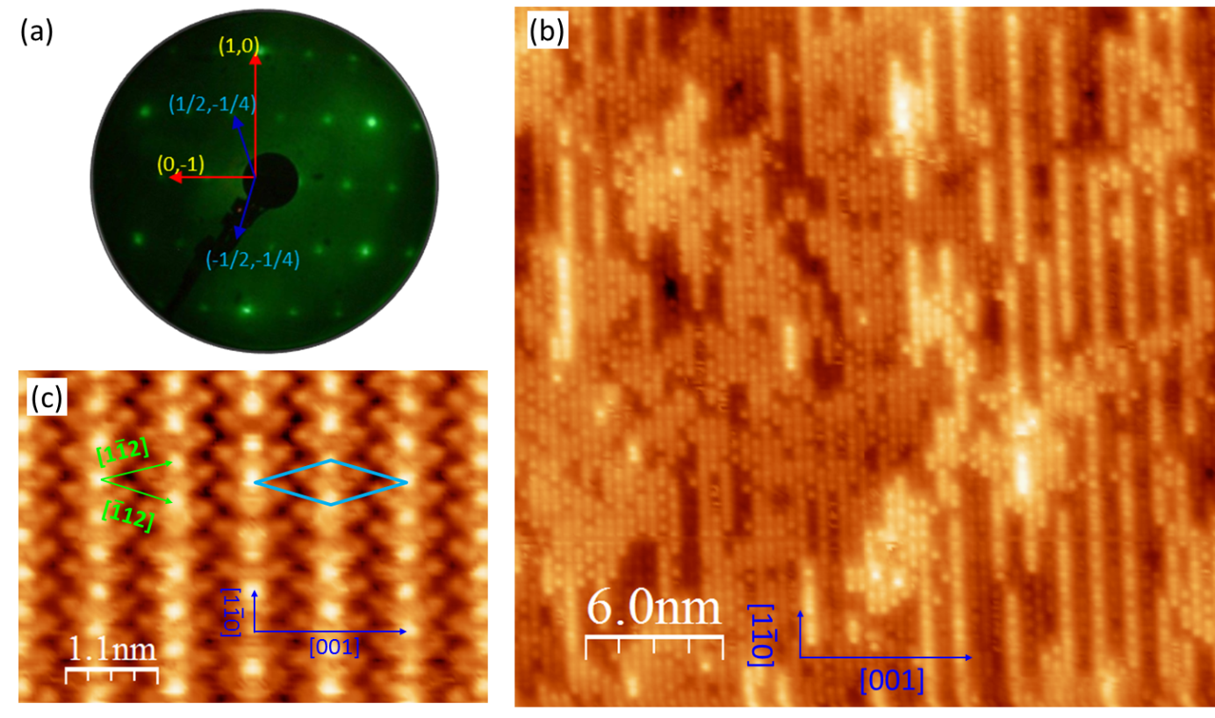

Figure 2. SRPES data of O 2s and Sn 4d of c(2×4)SnO_{x}/Pt(110) (a and b).
Figure 3. Atomic models of c(2×4) surface and their corresponding simulated STM images with tip bias at -50 mV.
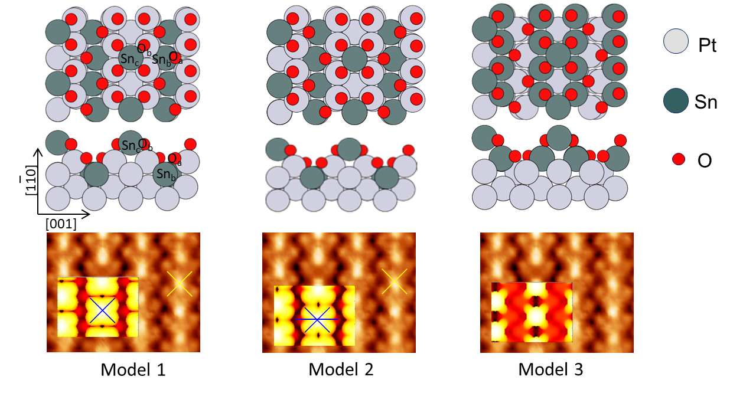

Figure 4. CO adsorption on c(2×4)SnO_{x}/Pt(110) nano-oxides and Pt(110) surface: (a) CO with signal at m/z =28, (b) C¹⁸OO at m/z =46, and (c) plot of peaks area vs total dosed CO amount.

Figure 5. DFT results of CO adsorption on c(2×4)SnO_{x}/Pt(110) surface.
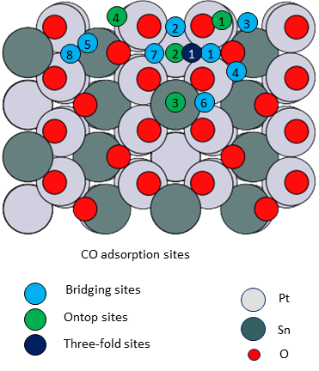

Table 1. Sn 4d and O 2s SRPES fitting data of the two SnO_{x}/Pt(110) nano-oxides.
c(2×4)SnO_{x}/Pt(110)
Sn 4d and O 2s | Normal Emission (90°) |  |  | Grazing Emission (30°)
Sn 4d and O 2s | BE  (eV) | Peak area (%) |  | BE  (eV) | Peak area  (%)
Sn_{a} (Sn-Pt) | 24.7 | 7 |  | 24.7 | 5
Sn_{b} (Sn(II)) | 25.6 | 59 |  | 25.6 | 60
Sn_{c} (Sn(IV)) | 26.1 | 34 |  | 26.0 | 35
O_{a} (Pt-O-Sn) | 20.5 | 30 |  | 20.4 | 30
O_{b} (Sn-O-Sn) | 21.9 | 53 |  | 21.8 | 59
O_{c} (-OH or H₂O_{ad}) | 23.1 | 16 |  | 23.1 | 11

Table 2. Adsorption Energies of CO on the c(2×4)SnO_{x}/Pt(110) surface (Model 1 of Figure 3)
Original position | Final position | Product | Energy
B1 | B1 | CO₂ | -2.6
B2 | Desorbed | CO | -
B3 | Desorbed | CO | -
B4 | O1 | CO2 | -3.4
B5 | O1 | CO2 | -3.4
B6 | O1 | CO2 | -3.4
B7 | O1 | CO | -
O1 | O1 | CO2 | -3.4
O2 | Desorbed | CO | -
O3 | Desorbed | CO | -
TF1 | Desorbed | CO | -

The table of contents
A new type of SnO_{x} nano-oxide on the Pt(110) surface is reported. This novel phase is characterized by STM, LEED and XPS, and its chemical activity toward the CO oxidation is investigated by TPD. Basing on these experimental results, the atomic model of the surface and its reaction mechanism towards CO are deduced and confirmed by DFT calculations. Interestingly, the SnO_{x} film can impart the Pt(110) an improved tolerance to CO poisoning by acting as a reservoir for oxygen species, which can spillover the adjacent Pt regions and produce CO_{2.}

Keyword: Nano-oxide, photoemission spectroscopy, STM, DFT, CO reactivity

Jian Zheng, Michael Busch, Luca Artiglia, Tomáš Skála, Jan Rossmeisl, Stefano Agnoli*

Title: Multiple reaction paths for CO oxidation on a two dimensional SnO_{x} nanoxide on the Pt(110) surface: intrinsic reactivity and spillover

ToC figure ((Please choose one size: 55 mm broad × 50 mm high or 110 mm broad × 20 mm high. Please do not use any other dimensions))

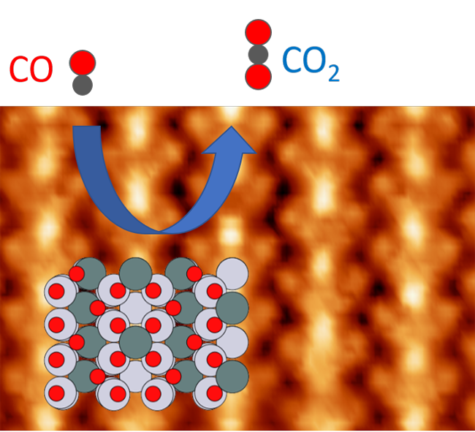

Copyright WILEY-VCH Verlag GmbH & Co. KGaA, 69469 Weinheim, Germany, 2016.

Supporting Information

Multiple reaction paths for CO oxidation on a two dimensional SnO_{x} nanoxide on the Pt(110) surface: intrinsic reactivity and spillover

Jian Zheng, Michael Busch, Luca Artiglia, Tomáš Skála, Jan Rossmeisl, Stefano Agnoli*

Figure S1. Atomic models of c(2×4) surface with various bulk and their corresponding simulated STM images with tip bias at -50mV.
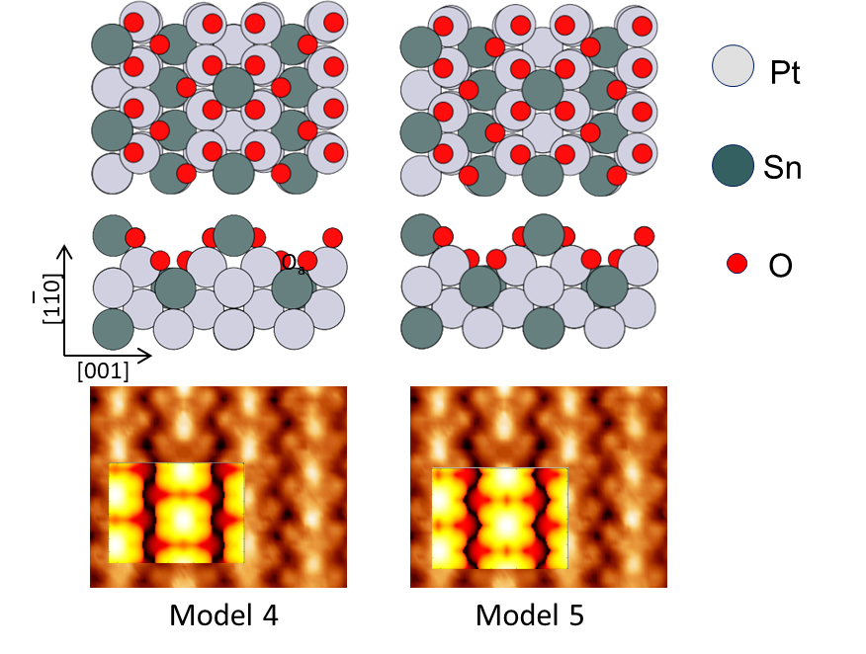

Figure S2. DFT results of CO adsorption on c(2×4)SnO_{x}/Pt(110) surfaces for Model 4 and 5 of Figure 3
Table S1. Adsorption Energies of CO on the c(2×4)SnO_{x}/Pt(110) surface (Model 4 of Figure S1)

Original position | Final position | Product | Energy
B1 | B1 | CO2 | -2.8
B2 | Desorbed | CO | -
B3 | Desorbed | CO | -
B4 | O1 | CO2 | -3.1
B5 | B5 | CO2 | -
B6 | O1 | CO2 | -3.1
B7 | Desorbed | CO | -
O1 | O1 | CO2 | -3.1
O2 | Desorbed | CO | -
O3 | Desorbed | CO | -
TF1 | Desorbed | CO | -

Table S2. Adsorption Energies of CO on the c(2×4)SnO_{x}/Pt(110) surface (Model 5 of Figure S1)

Original position | Final position | Product | Energy
B1 | B1 | CO2 | -2.6
B2 | Desorbed | CO | -
B3 | Desorbed | CO | -
B4 | B4 | CO2 | -2.4
B5 | Desorbed | CO | -
B6 | O1 | CO2 | -3.4
B7 | B7 | CO2 | -0.9
O1 | O1 | CO2 | -2.2
O2 | Desorbed | CO | -
O3 | Desorbed | CO | -
TF1 | Desorbed | CO | -

